dk;kZy;& jktdh; mPp ek/;fed fo/kky; tkylw ukud ¼Msxkuk½
dzekad@ys[kk &jkmekfo@tkuk@ fnukad
&%dk;kZy; vkns”k%&
for foHkkx jktLFkku ljdkj ds vkns”k dzaekd ,Q 1 ¼12½ ,QMh@:Yl@2005 t;iqj fnukad 03-09-2008 ds vuqlkj LFkkuh; dk;kZy; ds v/khu dk;Zjr fuEukfdr vf/kdkjh;ksa ,oa deZpkjh;ksa dks mudsa vkosnu fd;s tkusa ij foRrh; o’kZ 201 & 202 gsrq fuEukuqlkj mikftZr vodk”k ds udn Hkqxrku fd;s tkus dh Lohd`fr dh tkrh gSA bl Lohd`fr dk bUnzkt lEcf/kar vf/kdkjh deZpkjh dh ewy lsok iqfLrdk esa dj fn;k x;k gSaA
dze la[;k | Ukke vf/kdkjh deZpkjh | Ewky osru | Ukdnhdj.k gsrq Lohd`r fnuksa dh l[;k
1- | Jh jkefuokl | 40100 | 15
2- | Jh ujlhjke | 71300 | 15
3- | Jh fd”kukjke | 59500 | 15
4- | Jh dj.k flag jRuq | 59500 | 15
5- | Jh fuEckjke | 49500 | 15

iz/kkukpk;Z
jkmekfo tkylw ukud
izfrfyfi%&
1- Jheku midks’kkf/kdkjh] Msxkuk
2- lacaf/kr dkfeZd Jh -----------------------------
3- dk;kZy; izfr
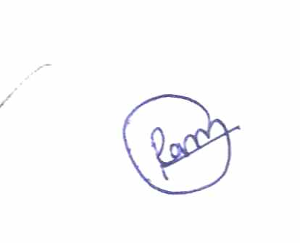
iz/kkukpk;Z
jkmekfo tkylw ukud

